CW DAY-7

App.js

import { Axios } from 'axios'

import Post from './components/Acesspost/Post'

import AxiosPost from './components/Acesspost/Post'

const App = () =>

{

  return (

    <>

    {

      <AxiosPost/>

    }

    </>

  )

}

export default App

Get.js

import axios from 'axios'

import React, { useEffect,useState } from 'react'

const AxiosGet = () => {

    const [books,setBooks]=useState([]);

    useEffect(()=>{

        const fetchData=async()=>{

         try{

          const response=await axios.get("http://localhost:8080/book")

          console.log(response.data)

              setBooks(response.data);

         }

         catch(error){

  console.log(error)

         }};

       fetchData();

    },[]);

  return (

    <div>

        <table>

            <thead>

           <tr>

            <th>Id</th>

            <th>Book title</th>

            <th>Author name</th>

           </tr>

            </thead>

            <tbody>

            {books.map((book)=>(

                <tr key={book.id}>

                    <td>{book.id}</td>

                    <td>{book.title}</td>

                    <td>{book.author}</td>

                </tr>

            ))}

            </tbody>

        </table>

    </div>

  )

}

export default AxiosGet

DB.json

{

  "book": [

    {

      "id": 1,

      "title": "json-server",

      "author": "typicode"

    },

    {

      "id": "2",

      "title": "book of thor",

      "author": "king"

    }

  ]

}

Output

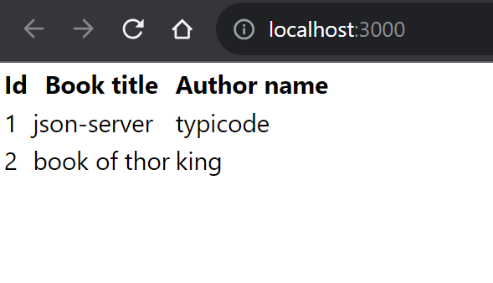

-------------------------------------------------------------------------------------------------------------------------------------

POST METHOD

import axios from 'axios';

import React, { useRef } from 'react'

const AxiosPost = () => {

    const bookIdRef = useRef("");

    const bookTitleRef = useRef(null);

    const bookAuthorRef = useRef(null);

    const handlePost = async () => {

        const data = {

            id: bookIdRef.current.value,

            title: bookTitleRef.current.value,

            author: bookAuthorRef.current.value

        };

        try {

            const response = await axios.post("http://localhost:8080/book", data);

            console.log(response)

        } catch (error) {

            console.log(error)

        }

    }

    return (

        <div>

            <input type='text' ref={bookIdRef} />

            <input type='text' ref={bookTitleRef} />

            <input type='text' ref={bookAuthorRef} />

            <button onClick={handlePost}>Post</button>

        </div>

    )

}

export default AxiosPost

OUTPUT

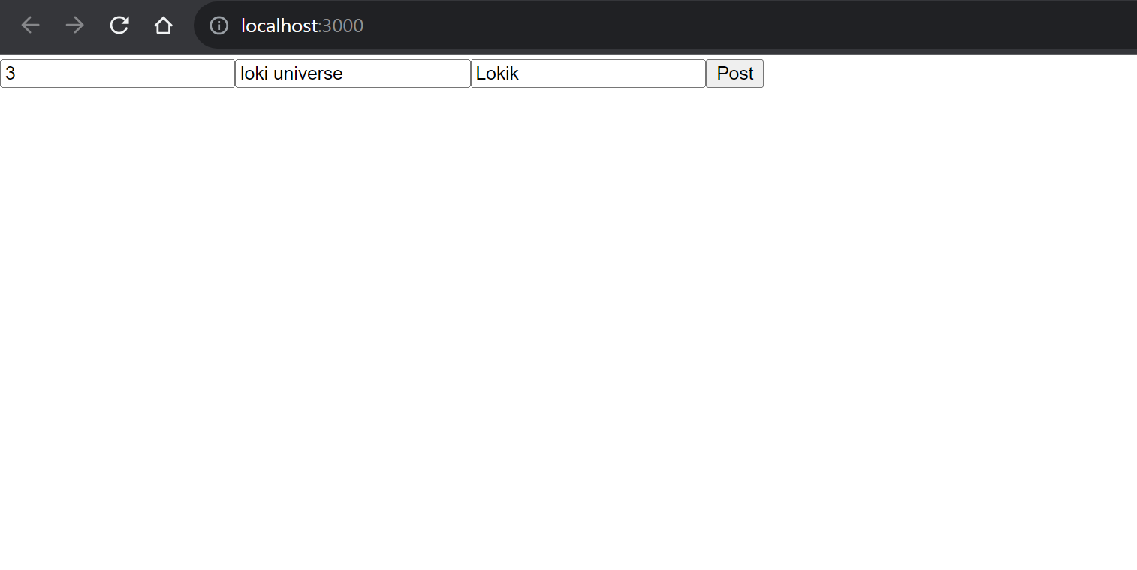

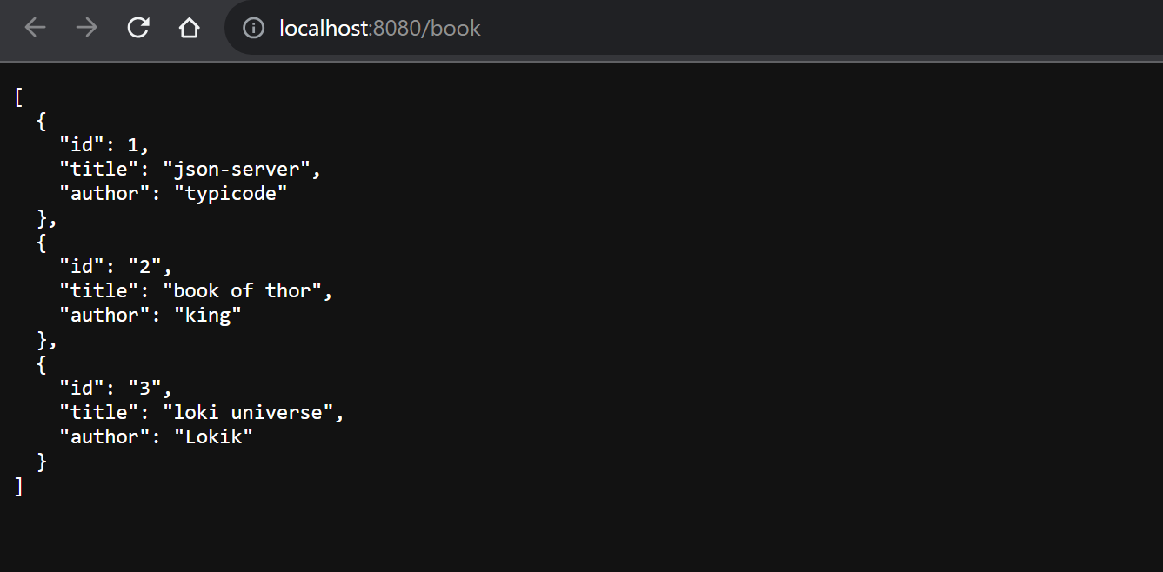

Delete

import React, { useState } from 'react';

import axios from 'axios';

const AxiosDelete = () => {

  const [bookId, setBookId] = useState("");

  const [message, setMessage] = useState("");

  const handleDelete = async () => {

    try {

      const response = await axios.delete(`http://localhost:8080/book/${bookId}`);

      setMessage(`Book with ID ${bookId} deleted successfully`);

    } catch (error) {

      setMessage(`Error deleting book with ID ${bookId}`);

    }

  };

  return (

    <div>

      <h2>Delete Books</h2>

      <label>

        Enter Book ID to Delete:

        <input

          type='text'

          value={bookId}

          onChange={(e) => setBookId(e.target.value)}

        />

      </label>

      <button onClick={handleDelete}>Delete Book</button>

      {message && <p>{message}</p>}

    </div>

  );

};

export default AxiosDelete;

OUTPUT

